
Daniel P. McCoy
County Executive
County of Albany
Office of the Executive
112 State Street
Albany, New York 12207-2021
(518) 447-7040 - FAX (518) 447-5589
www.albanycounty.com
Michael P. McLaughlin, Jr.
Deputy County Executive

August 5th, 2025

Honorable Joanne Cunningham, Chairwoman
Albany County Legislature
112 State Street, Room 710
Albany, New York 12207

Dear Chairwoman Joyce,

This request seeks authorization to amend Resolution No. 593 for 2023 and convey the property located at 2A Lincoln Avenue and 201 Spring Street Road in the Town of Colonie. The Albany County IDA has expressed interest in acquiring the parcels for the purpose of promoting employment and the development and retention of industry in Albany County, which falls in line with the County Disposition Plan. The properties will be transferred to the County Industrial Development Agency by a Deed by Assignment.

If you should have any questions, please do not hesitate to contact me.

Sincerely
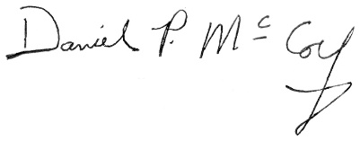

Daniel P. McCoy
Albany County Executive

cc: Hon. Dennis Feeney, Majority Leader
Hon. Frank Mauriello, Minority Leader
Rebekah Kennedy, Majority Counsel
James Curran, Minority Counsel

