July 18, 2025

Honorable Joanne Cunningham, Chairwoman
Albany County Legislature
112 State Street, Room 710
Albany, NY 12207

Re: Gun Involved Violence Elimination
(GIVE) Grant Renewal

Dear Chairwoman Cunningham:

Enclosed is a request for Legislative Action for permission to renew The Probation Department’s contract with the New York State Division of Criminal Justice Services (DCJS) regarding Gun Involved Violence Elimination (GIVE) grant. This year we have been awarded $380,672, which is a slight increase for salaries. This amount will be reflected in the 2026 Probation budget. The GIVE Grant pays for personnel, training material, GPS, incentives, and overtime for related work. This continues to be a partnership with the Albany County District Attorney Office, the Albany Police, the Albany County Sheriff, and NYS Division of Criminal Justice Services.

It is respectfully requested this be considered. If you have any questions or need additional information, please do not hesitate to contact me directly at (518) 487-5194.

Sincerely,

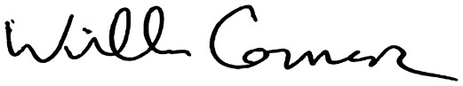

William Connors
Probation Director
WC/km
Enc.

cc: Honorable Dennis Feeney, Majority Leader
Honorable Frank Mauriello, Minority Leader
Rebekah Kennedy, Esq., Majority Counsel
James Curran, Esq., Minority Counsel

