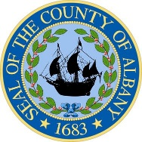

DANIEL P. McCOY
County Executive

MARIBETH MILLER, RN, BSN, MS
Interim Commissioner of Health

TRICIA BULATAO, MS, RDN
Deputy Commissioner of Health

RANSOM E. MOORE III
Assistant Commissioner
Finance & Administration

Department of Health
County of Albany
175 GREEN STREET
ALBANY, New York 12202

The Dr. John J.A. Lyons
albany county health facility
- 447-4580 FAX (518) 447-4698
www.albanycountyny.gov

July 30, 2025

Hon. Joanne Cunningham, Chairwoman
Albany County Legislature
112 State St., Rm. 710
Albany, NY 12207

Dear Chairwoman Cunningham:

The Albany County Department of Health (ACDOH) requests authorization to amend its 2025 budget to reflect anticipated spending of the Opioid Settlement Funds throughout the remainder of the 2025 calendar year. ACDOH will utilize this funding to provide opioid prevention services, conduct overdose surveillance, and coordinate rapid response.

Please don’t hesitate to contact me if you have any questions or need additional information.

Sincerely,
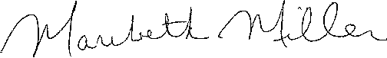

Maribeth Miller, BSN, MS
Interim Commissioner of Health

cc: Hon. Dennis Feeney, Majority Leader
Hon. Frank Mauriello, Minority Leader
Rebekah Kennedy, Majority Counsel
James Curran, Minority Counsel

Enclosures

