
Daniel P. McCoy
County Executive
County of Albany
Office of the Executive
112 State Street
Albany, New York 12207-2021
(518) 447-7040 - FAX (518) 447-5589
www.albanycounty.com
Michael P. McLaughlin, Jr.
Deputy County Executive

August 1st, 2025

Honorable Joanne Cunningham
Chair, Albany County Legislature
112 State St. Rm. 710
Albany, NY 12207

Dear Chairwoman Cunningham,

This request is for authorization for to convey the property located at 275 Second Avenue, Albany NY 12209 located in the City of Albany to the former owner Basdeo Seepersad for $81,526.05. This conveyance falls in line with the newly adopted County Disposition Plan as it is being sold to former owners:

“Requests for reacquisition by former owners, or by the estates of former owners, of properties may be considered while the property remains in County ownership. If and when certified funds are deposited in an amount required by the Legislature or by Court Order, the County shall convey the parcel back to the former owner, or the estate thereof, as per RPTL § 1136(4)(b), thereby restoring potential equity in the property to the them.”

The purchasers will be subject to all closing costs.

Sincerely,

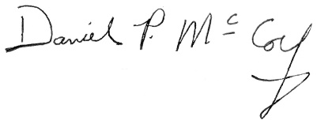

Daniel P. McCoy
Albany County Executive

cc: Hon. Dennis Feeney, Majority Leader
Hon. Frank Mauriello, Minority Leader
Rebekah Kennedy, Majority Counsel
James Curran, Minority Counsel

