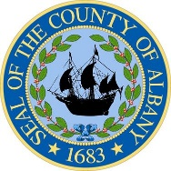

DANIEL P. McCOY
County Executive

MARIBETH MILLER, RN, BSN, MS
Interim Commissioner of Health

TRICIA BULATAO, MS, RDN
Deputy Commissioner of Health

RANSOM E. MOORE III
Assistant Commissioner
Finance & Administration

Department of Health
County of Albany
175 GREEN STREET
ALBANY, New York 12202

The Dr. John J.A. Lyons
albany county health facility
- 447-4580 FAX (518) 447-4698
www.albanycountyny.gov

July 30, 2025

Hon. Joanne Cunningham, Chairwoman
Albany County Legislature
112 State St., Rm. 710
Albany, NY 12207

Dear Chairwoman Cunningham:

The Albany County Department of Health (ACDOH) requests authorization to accept funds and to amend its 2025 budget for the multistate JUUL Labs Inc. (JUUL) settlement for its role in fueling the youth vaping epidemic. New York State will receive a total of $112.7 million through this settlement and Albany County has been allotted $1,055,715. ACDOH will use the settlement funds, which will be paid in eight annual increments of $131,964, for evidence-based measures to combat underage vaping and e-cigarette addiction. Three of these payments totaling $395,892 will be received upfront in 2025 and the remaining five payments will be made through 2030.

Please don’t hesitate to contact me if you have any questions or need additional information.

Sincerely,
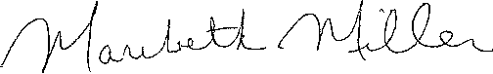

Maribeth Miller, BSN, MS
Interim Commissioner of Health

cc: Hon. Dennis Feeney, Majority Leader
Hon. Frank Mauriello, Minority Leader
Rebekah Kennedy, Majority Counsel
James Curran, Minority Counsel

Enclosures

